the BIKE DUMP Workshop 4 – Gears
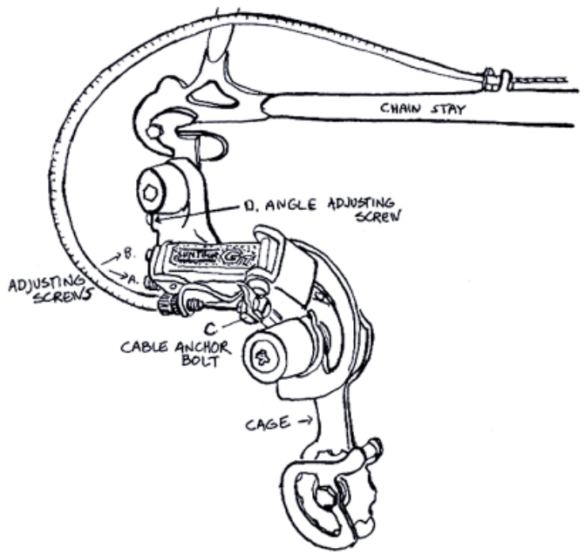
The term “drivetrain” referrs to the chain, the front chainrings, the front derailleur, the rear cogs and the rear derailleur.
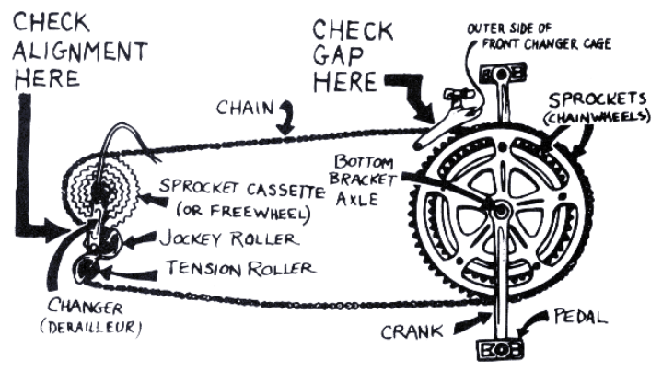
Derailleurs shift the chain up and down the front chainrings and the rear cogs. This happens through tension on the shifter cable connected to the shifter. Typically the rear derailleur is connected to the right shifter and the front derailleur is connected to the left shifter. Assuming that the derailleurs function properly, there are two ways to adjust the derailleur: 1) adjusting cable tension, and 2) adjusting the limit screws.

Rear Derailleur
1.) Inspect
a) Check Adjustment by pedaling the bike and using the shift lever to shift the rear derailleur. Does it
shift smoothly? Does the chain fall off on either side of the rear gear cluster? Look at the derailleur from the rear. Is it bent? Can you push or pull the derailleur into the spokes or frame?
b) Derailleur hanger. In addition to the derailleur itself, the hanger that the derailleur is attached to also can get bent. This will keep the derailleur from lining up with the cogs and keep the chain from shifting improperly.
c) Cables and housing OK? are they too short or too long? rusted, cracked or frayed? The proper function of a derailleur depends on the cable being able to move freely and easily through the housing.
d) Shifters pivot easily and are not too loose?

2.) Disassemble
a) Unlock the shifter cable from the derailleur On the underneath side of the derailleur find the anchor
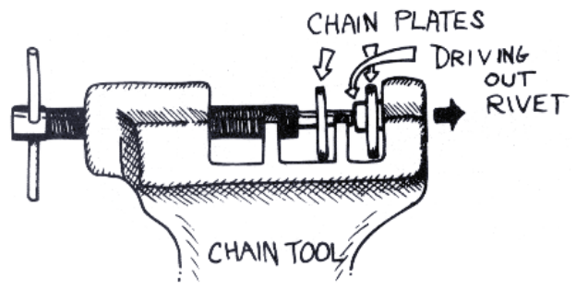
bolt that holds the shift cable. Loosen that bolt.
b) Break the chain with a chain tool In order to remove the derailleur from the bike its necessary to “break” the chain, i.e. open up a link by pushing a pin most of the way out. Just remember, DON’T push the chain pin all the way out!! That’s the pin you’ll use to put the chain back together again. Remember which side of the chain was Up at the point where you break it. Some people think that because chains wear in conjunction with the rear cogs, if you put the chain on upside down from how it was on before you may get a lot of slipping in the gears or chain suck.

3.) Adjust
a) Set your Limiter Screws. Remember, derailleurs are built to pivot from side to side. They are not built to automatically know how far they should pivot. This is why we invented limiter screws. If you’ve ever had your chain fall into your spokes or get trapped in between your gears and the frame you know what its like to have misadjusted limit screws.
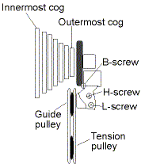
i) Look down at the derailleur and find two screws one marked (H)igh and the other marked (L)ow. These are your limit screws. They have nothing to do with have the chain shifts from one cog to another, except for the innermost and outermost cogs. This is because these screws control how far the derailleur can travel from side to side.
ii) Holding your index finger against the frame and your thumb against the derailleur, begin pedaling
the bike and push the derailleur with your thumb all the way as far as you can in towards the spokes.
If the chain passes the edge of the biggest cog and falls into spokes then the (L) limiter screw is not
screwed in far enough, thus allowing the derailleur to pass beyond the largest chainring (and possibly
into the spokes!). If the chain will not shift onto the largest cog, then your (L) limiter screw is
screwed in too far. When your (L)ow gear limiter screw is set correctly, the chain should move all
the way onto the largest cog, but not fall into the spokes. At that point, the jockey wheels should be
in line with the largest chain ring and there should be NO!!!! grinding sounds while you pedal the
bike.
iii) Now take your hand off the derailleur and let it fall back into the highest gear as you pedal the bike.
Your (H)igh gear limiter screw should keep the chain from passing beyond the smallest cog and
falling into the frame. It should also allow that the chain to run smoothly on the highest gear (on the
smallest rear cog). Try as hard as you can to pull the derailleur so that the chain would fall into the
frame. If the chain does fall into the frame your (H)igh gear limiter screw needs to be screwed in a
little farther in order to limit the derailleurs movement towards the frame. If the derailleur holds its
position and the chain does not grind off the gear your (H)igh limiter screw is All Set!

Note: Setting the limitting screws for the front derailleur follows the same general process as the rear derailleur does.

4.) Attach the derailleur cable
a) Make sure that the shifter is all the way down i.e. its in the position of the highest gear, where it does
not pull on the cable at all.
b) Route cable properly, making sure that the ball end fits snugly into the shifter and that the cable runs
the proper route from the shifter to the derailleur. This task may sound easy but it can be deceiving.
In some cases the cable may run over or under the bottom bracket or may run with or without
housing at different spots. Always try to remember how the cables were run when you first saw the
bike.
c) Make sure that all barrel adjusters have space to adjust in both directions (usually there is only one
on the back side of the derailleur that the cable routes through though on some of the newer bikes
there is a second one on the either the down tube or as a part of the shifter). If your barrel adjusters
are either screwed in all the way or out all the way you won’t have the ability to adjust cable tension
once you attach the cable.
d) Make sure derailleur is in the highest gear (i.e. your chain is on the smallest rear cog). With your
shifters in the highest gear and your derailleur in the highest gear, you make sure that you are not
going to end up with a lot of extra cable slack once you attach the cable.
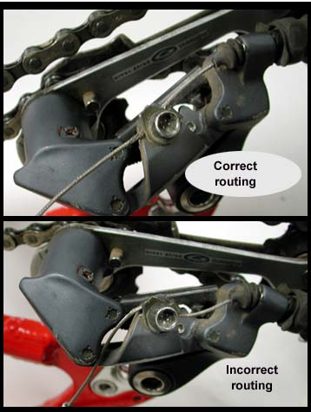
5.) Attach Cable. Look carefully at the derailleur cable anchor bolt and the surface of the derailleur against which the cable clamps. Usually you can tell how the cable wants to be routed by looking
for a slight groove in either the bolt or the derailleur itself. This groove indicates what line the cable should follow. Nine times out of ten this will be a straight line out of the barrel adjuster. Now pull
the cable through and bolt it down making sure to only pull the cable hand-tight. If you use a fourth hand or pull the cable tight with a pair of pliers, the cable will be too tight and the derailleur will be unable to shift into the highest gear.

6.) Adjust Your Shifting
This process is slightly different for index shifting than it is for friction shifting. Index shifting is the one “click,” one shift mechanism. It’s made so that there should be no guess work when it comes to finding your gear. Friction shifting doesn’t have any “clicks.” You just have to look around for the gear you want. The positive aspect of friction shifting is that if your shifting isn’t dependent on these “clicks”. If your cable tension and “clicks” are not completely synchronized your bike won’t shift properly. With friction shifting, even if you don’t have perfect cable tension you can still find the proper gear.
a) With friction shifters once you’ve set your limit screws and attached your cable most of your work
is done. Now all you have to do is make sure your cable has enough tension on it. You should be all
set. Try shifting the bike making sure that you don’t have to push the shifter beyond its limit to get
the bike into the lowest gear.
b) Index shifters are a little more difficult. You must fine-tune the cable tension. After pulling the cable
hand-tight and attaching the cable to the derailleur with the anchor bolt, then, while pedaling the
bike, shift the shifter up until you hear the first click. Now unscrew (or screw in!) your barrel
adjuster until the chain shifts up onto the second cog, and the center of the chain is directly over the
center of the cogs (as you look at the assembly from the rear of the bike). In theory, you now have
the correct cable tension to make each shift up to the next cog happen snappily with each next click.
With the shifter, move the chain up one to each gear cog. Do this all the way up to the lowest gear
and back down again. adjust your chain tension with the barrel adjuster if you hear any grinding
sounds in each gear, or if the chain moves sluggishly. NOTE: unscrewing the barrel adjustor moves
the derailleur (and thus the chain) in towards the wheel, screwing in the barrel adjuster moves the
derailleur out away from the wheel - why? (Hint: are you making the housing longer or shorter
relative to the cable?) Now you should be All Set!!
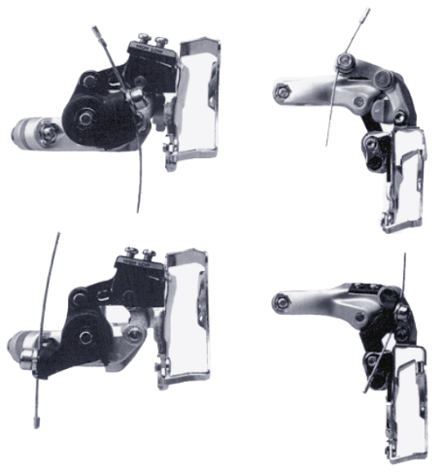
Front Derailleur
The type of front derailleur you’ve got depends
on two factors: 1) The direction that the cable
comes from to pull the derailleur, and 2) where
the parallelogram is postioned in relation to the
mounting of the derailleur itself. A top swing/
bottom pull would have the parallelogram positioned above the mounting of the derailleur
and the cable would be routed underneath the bottom bracket thus pulling the derailleur arm
from the bottom.

1.) Disassemble
a) Detach the derailleur cable by loosening the cable anchor bolt and let the cable hang loose
b) Unscrew the derailleur cage bolt, also called the entretois. This is the bolt at the back of the derailleur cage that separates the two cage arms. Be careful to keep track of the spacer from the entretois as well as the bolt itself. If you don’t unscrew this bolt, the chain will still be threaded
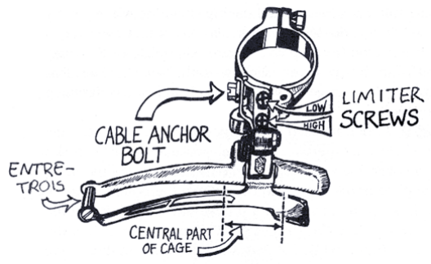
through the derailleur cage even after you’ve taken the derailleur off the bike. You have the option of breaking the chain in order to get the front derailleur off but unless you’re going to break the chain anyway, I don’t recommend removing the derailleur in this way.
c) Unscrew the derailleur mounting bolt
d) Remove the derailleur from the seat tube.

2.) Clean and Inspect
Take some light oil or solvent and a tooth brush and scrub the derailleur. Since there are so many
small parts, it’s nice to have a compressor hose around to spray the derailleur once you’ve scrubbed it
down. Inspect:
a) Cables and housing- Rusty, frayed, or broken? Cable bent too much to go back through the
housing?
b) Derailleur cage- Is it bent?
c) All bolts and nuts- Stripped?
d) Limiter screws- Turn easily and are not stripped?

3.) Reassemble (this is just disassembly in reverse.)
a) Thread the chain through the derailleur cage and replace the cage bolt (entretois), making sure not the forget the spacer on the bolt.
b) Reattach the derailleur to the seat tube of the frame, making sure the central part of the cage clears the teeth of the largest chain ring by 1 mm (in the case of some Biopace chain rings the distance may vary so make sure to spin your chain rings to be sure) and
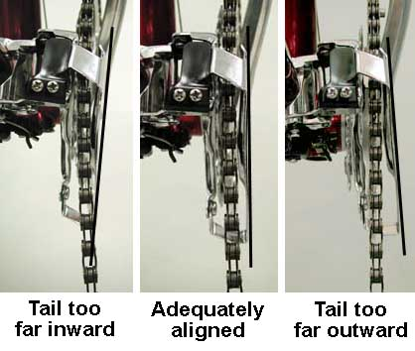
c) Make sure the outside edge of the cage is parallel to the chain when it is on large ring in the front and small cog in the back.
d) With your shifter all the way down, i.e. as if the chain were in the smallest chain ring, attach the
cable to the derailleur with the anchor bolt. As with the rear derailleur, the are many signs to tell you
how your cable should be routed. The best bet is to remember how it was routed before you took it
apart
e) If you are using a new cable, you must pre-stretch it at this point. After attaching it with the cable
anchor bolt, grab an exposed portion of the cable and pull it as hard as you can ten times.

4.) Adjust the front derailleur (instructions for Index Shifting and a Triple Chainring)
a) Put chain on big chain ring and little cog and set the outer limiter screw so that the cage just clears
the chain (1 mm or less).
b) Put chain on little chain ring and big cog, set inner limiter screw so that cage just clears chain on the
inside by 1 mm.
c) Make sure that each barrel adjustor is screwed all that way down and then unscrewed 2-3 clicks.
Loosen the cable anchor bolt, pull the cable through it until it is “hand-tight”, i.e. you pull the cable
taught with your hand and screw the anchor bolt back down on it - keep the derailleur in the position
you put it in in the previous step while you do this!
d) Keeping chain on big cog in back, shift onto big chain ring in front. Then shift back down onto the
center chainring. With a new cable (even though you have pre-stretched) adjust the cable tension so
that the derailleur cage is just barely brushing the chain on the inside. With an old cable, adjust it so
that the chain just barely clears the cage on the inside.
Note: for Friction Shifting, follow steps a) and b) of Section 1.) above, and you should be done.

